Concepcion Justine S.
7ANALYTICS

Midterm Lab Task 2. Data Preparation and Modeling using Power Query

CLEAN DATA:

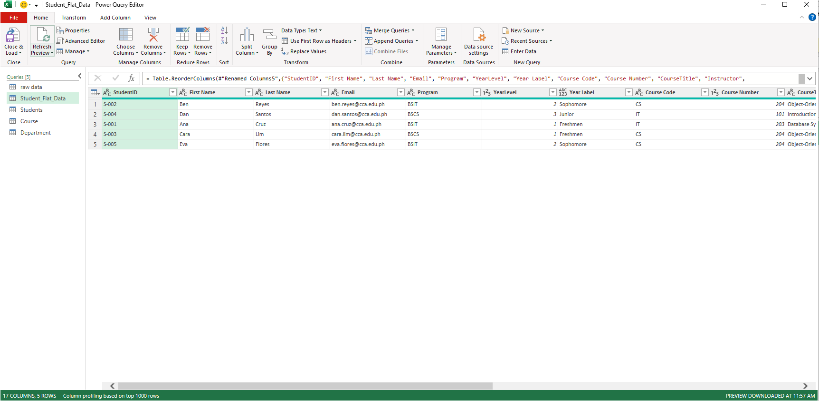
STUDENTS TABLE:
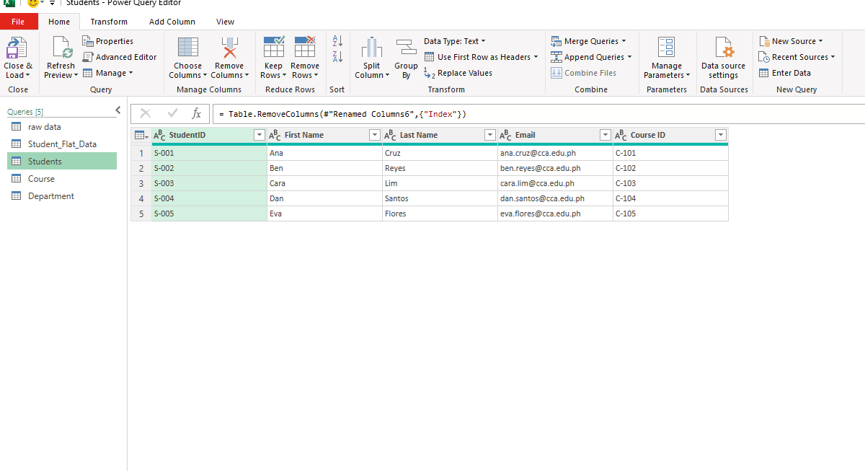

COURSE TABLE:

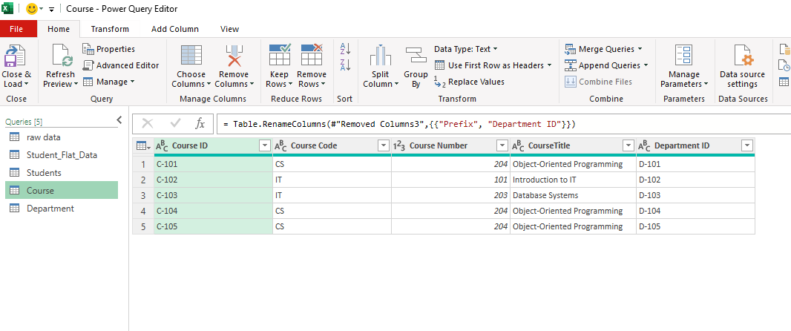
DEPARTMENT TABLE:

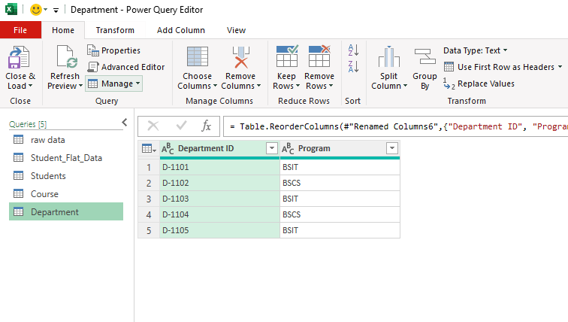

DATA MODEL:

